**ASSIGNMENT-02**

**USN: 4MT21CS024**

**QUES:01**

**JAVA CODE: sum**

import java.util.Scanner;

public class Sum {

public static void main(String[] args) {

int a,b,c;

Scanner sc=new Scanner(System.***in***);

System.***out***.println("Enter the value of a,b and c: ");

a=sc.nextInt();

b=sc.nextInt();

c=sc.nextInt();

int sum;

if(a!=13 && b!=13 && c!=13) {

System.***out***.println("The sum of a,b,c is :"+(sum=a+b+c));

}

else if(a==13) {

System.***out***.println("The sum is :0");

}

else if(b==13) {

System.***out***.println("The sum is: "+a);

}

else {

System.***out***.println("The sum is: "+(sum=a+b));

}

}

}

**Output for ques 01**:

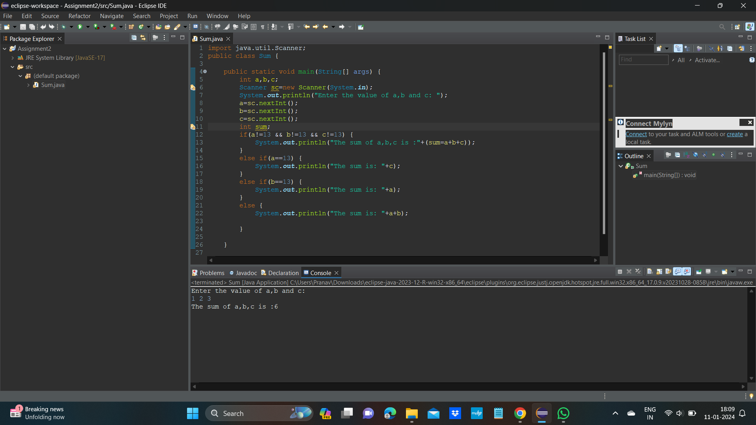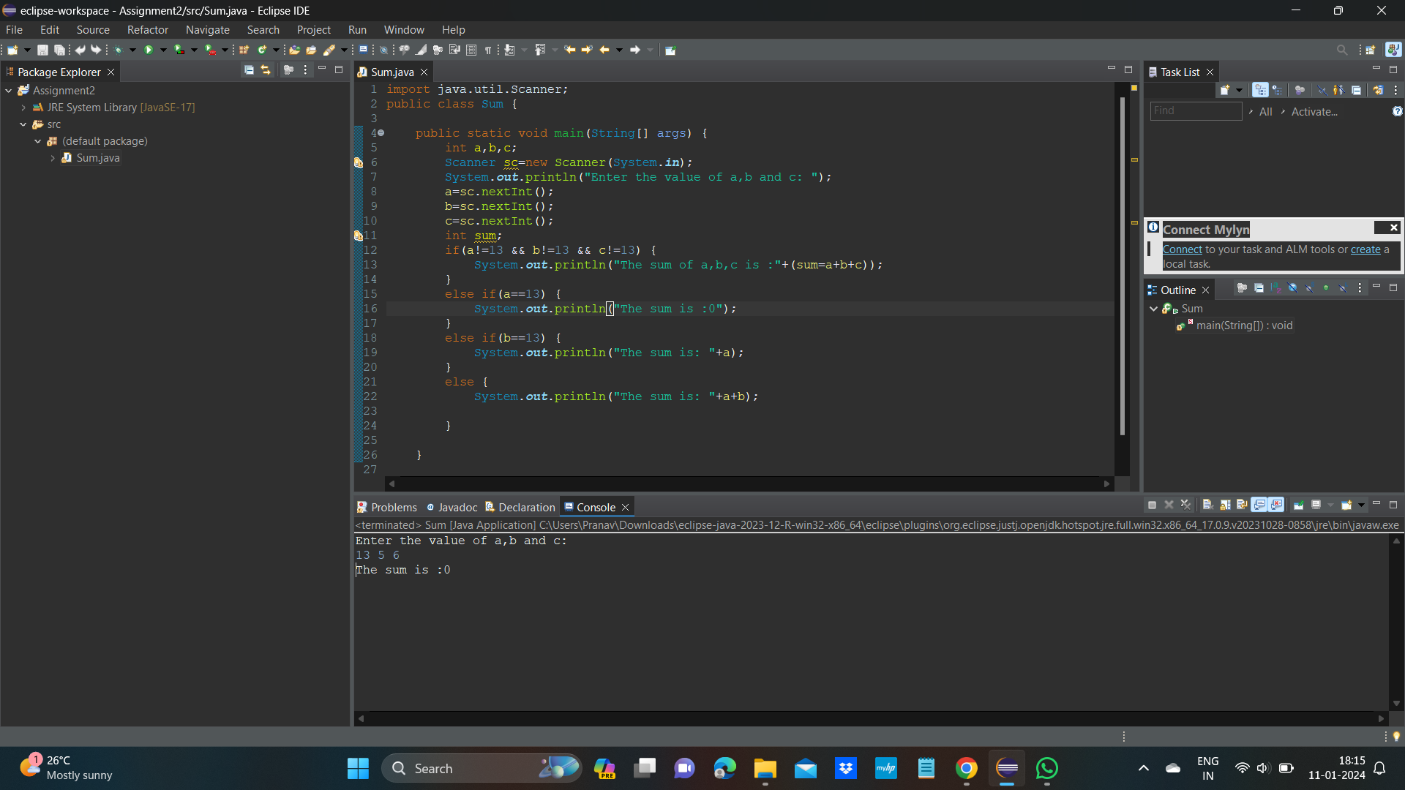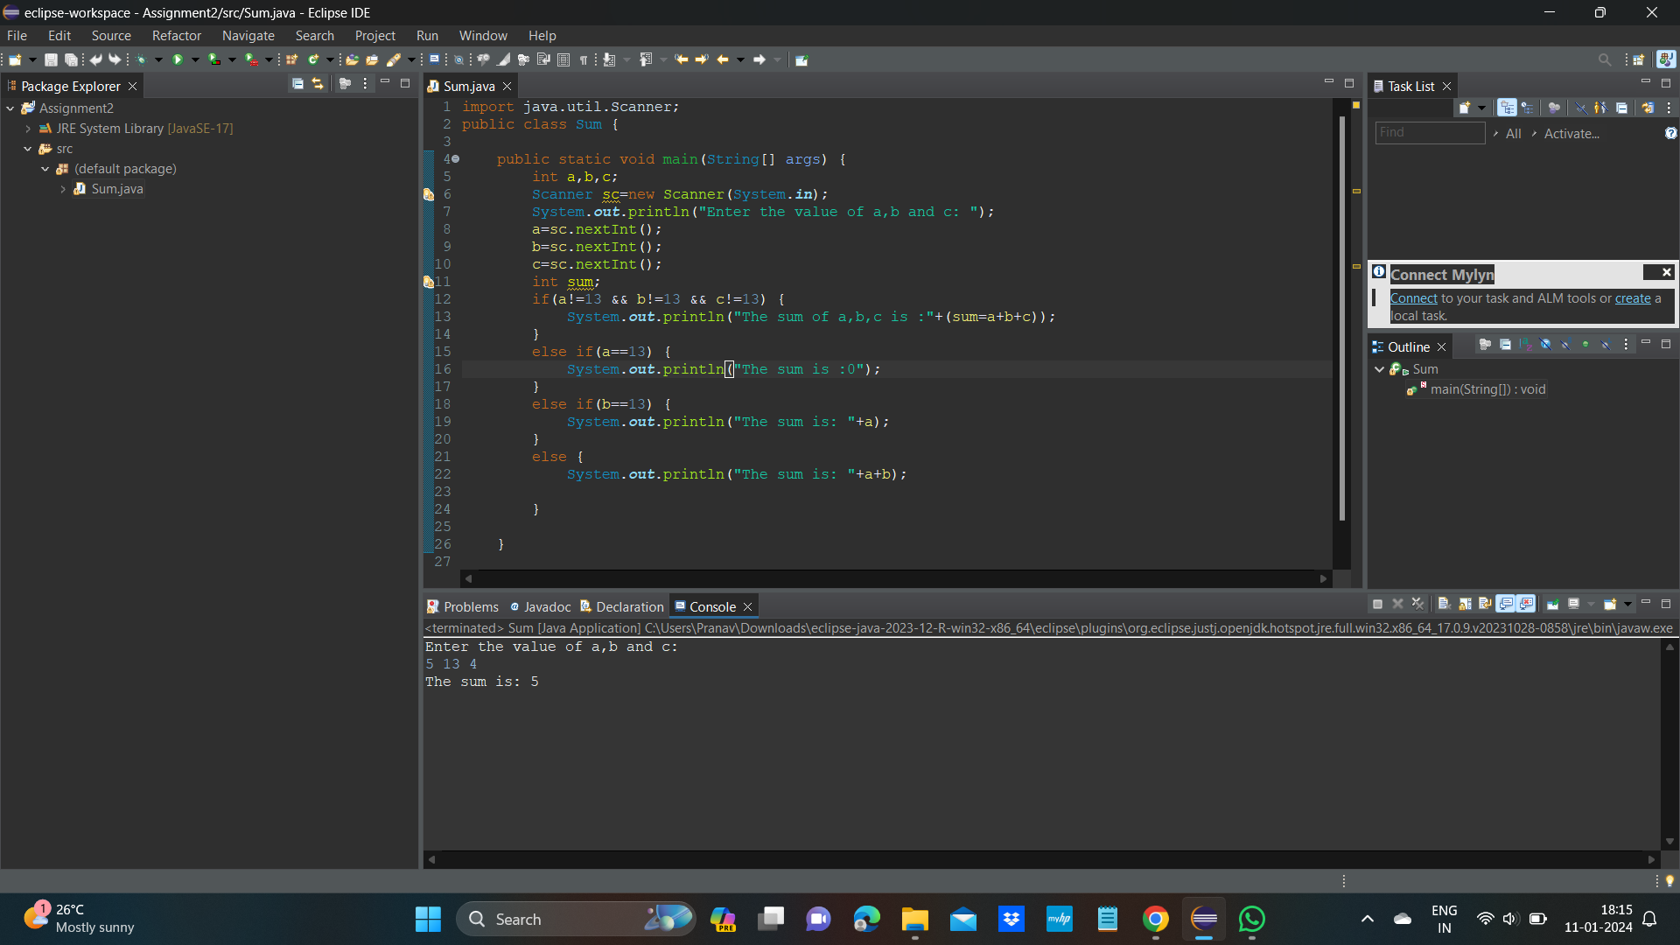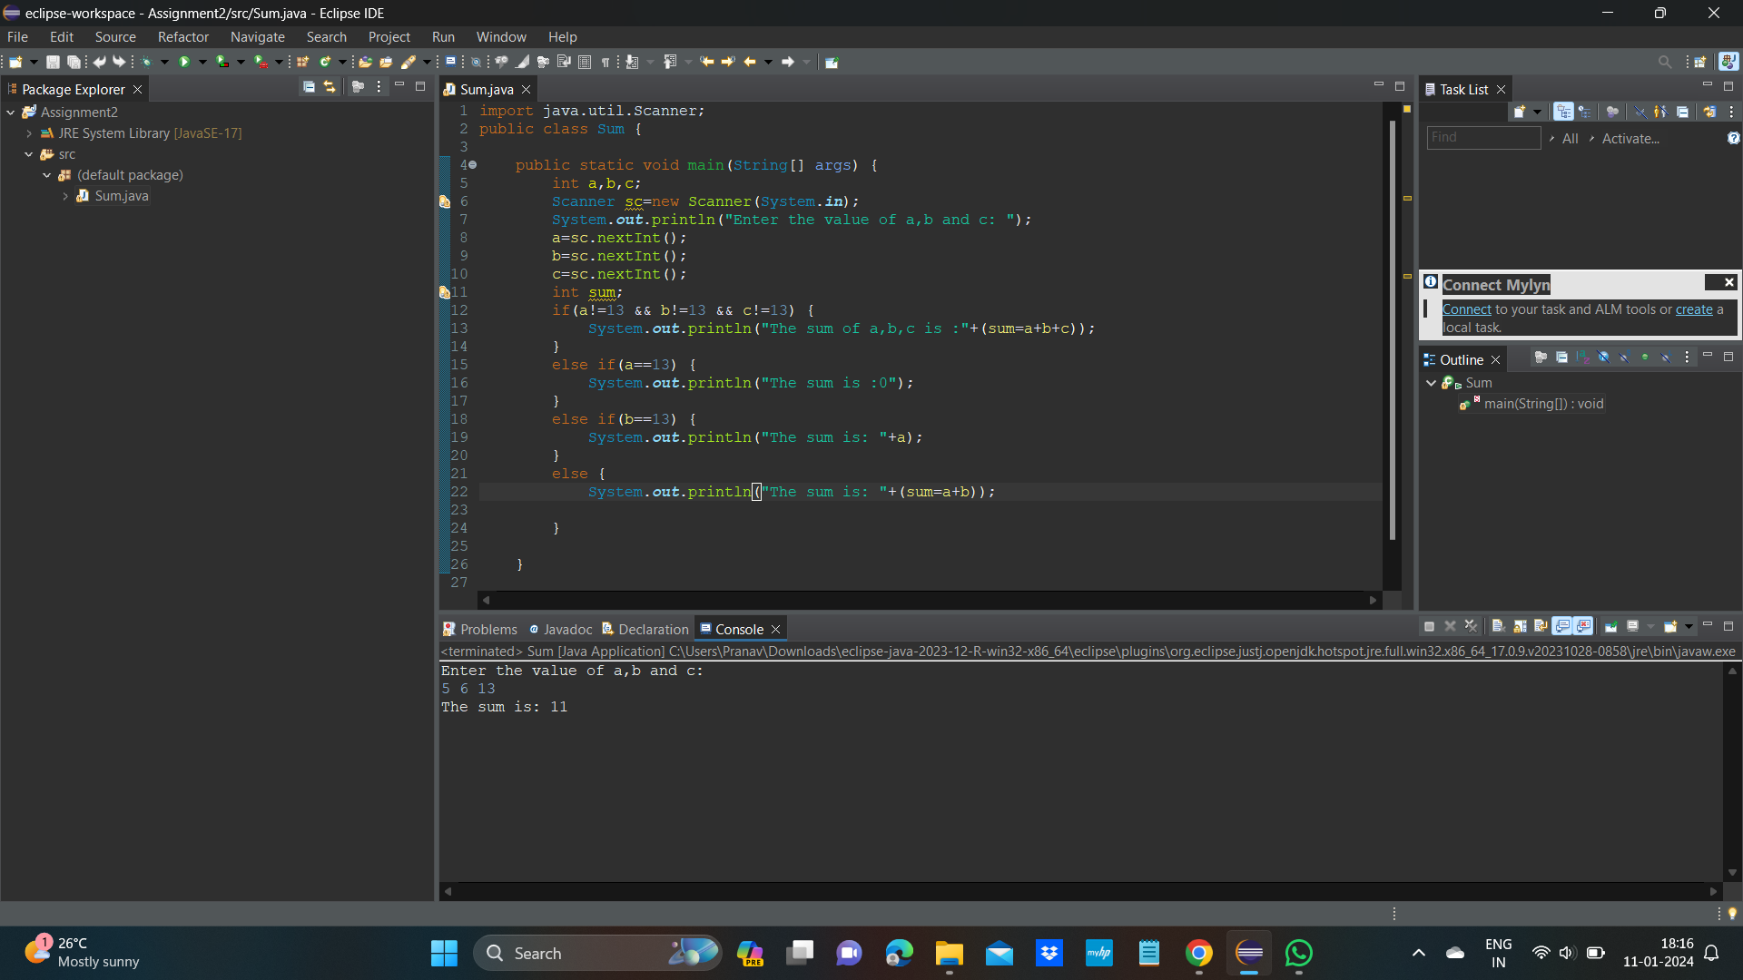

**Ques 02:teen problem**

**Java code:**

import java.util.Scanner;

public class Teen {

public static void main(String[] args) {

Scanner sc=new Scanner(System.***in***);

int a,b,c;

System.***out***.println("Enter the values of a,b and c:");

a=sc.nextInt();

b=sc.nextInt();

c=sc.nextInt();

int res=*noTeenSum*(a,b,c);

System.***out***.println(res);

}

public static int noTeenSum(int a,int b,int c){

a=*fixTeen*(a);

b=*fixTeen*(b);

c=*fixTeen*(c);

return a+b+c;

}

public static int fixTeen(int n){

if(n==15||n==16){

return n;

}

else if(n>=13&&n<=19){

return 0;

}

return n;

}

}

**Output for ques 02:**

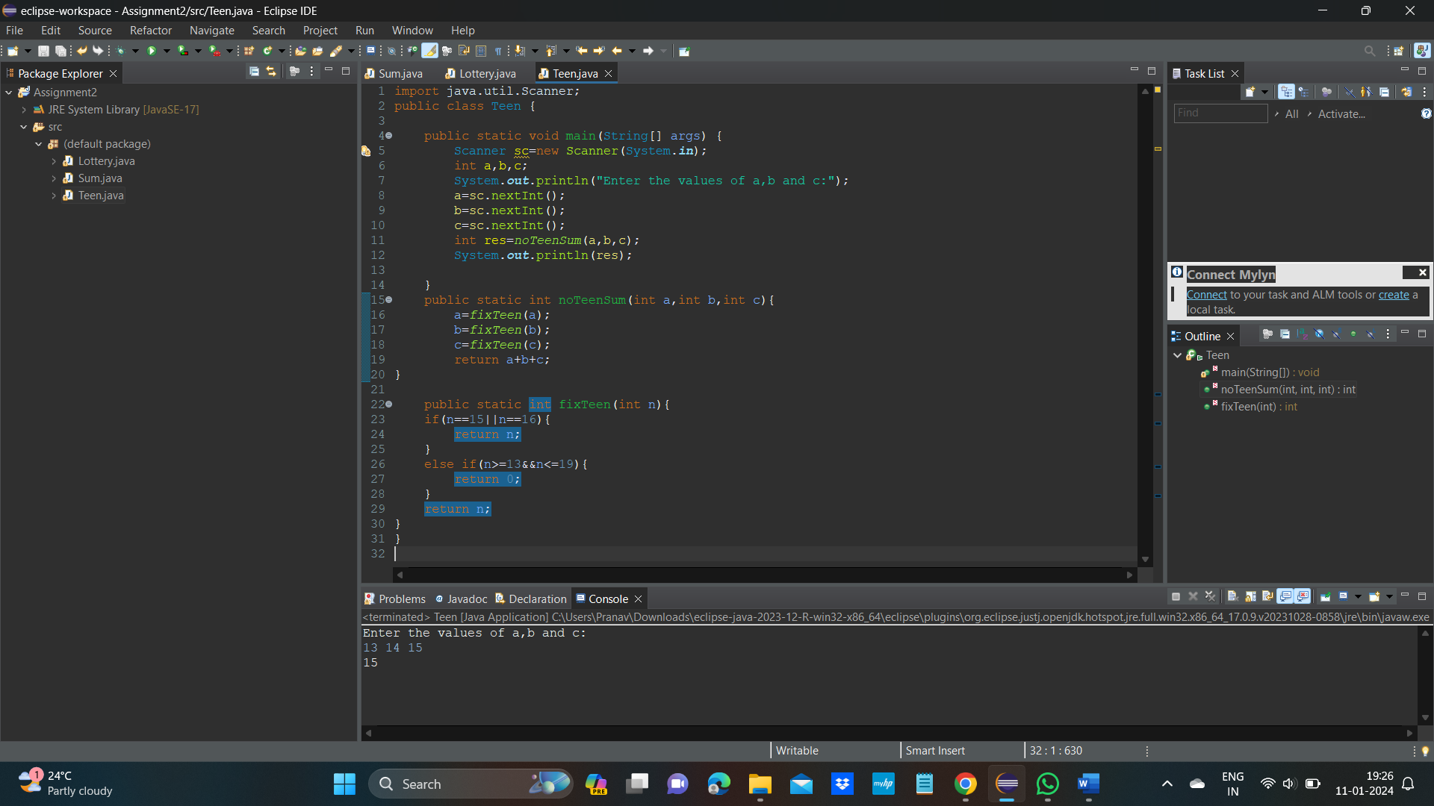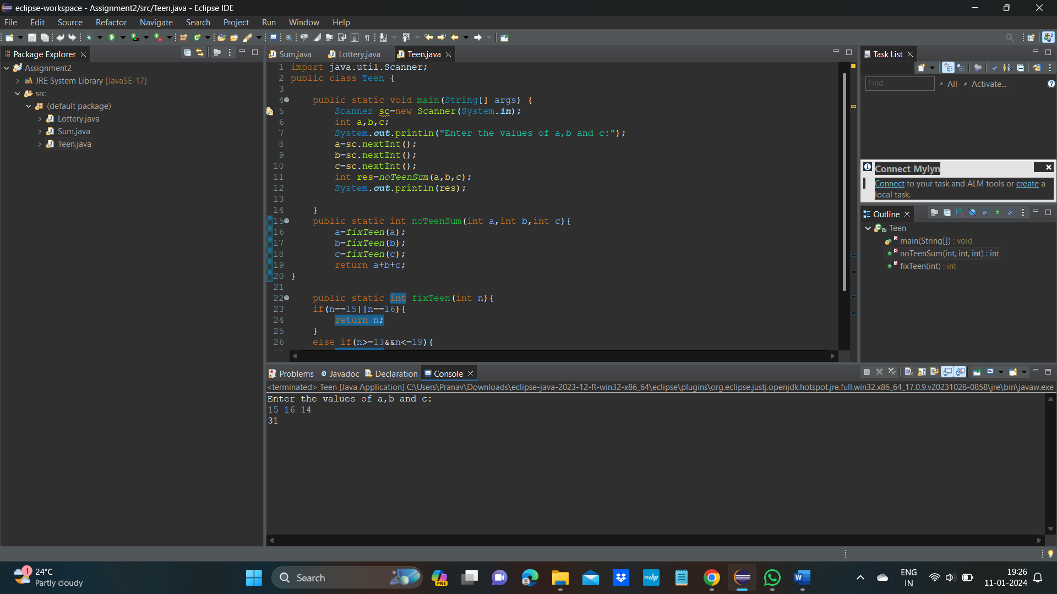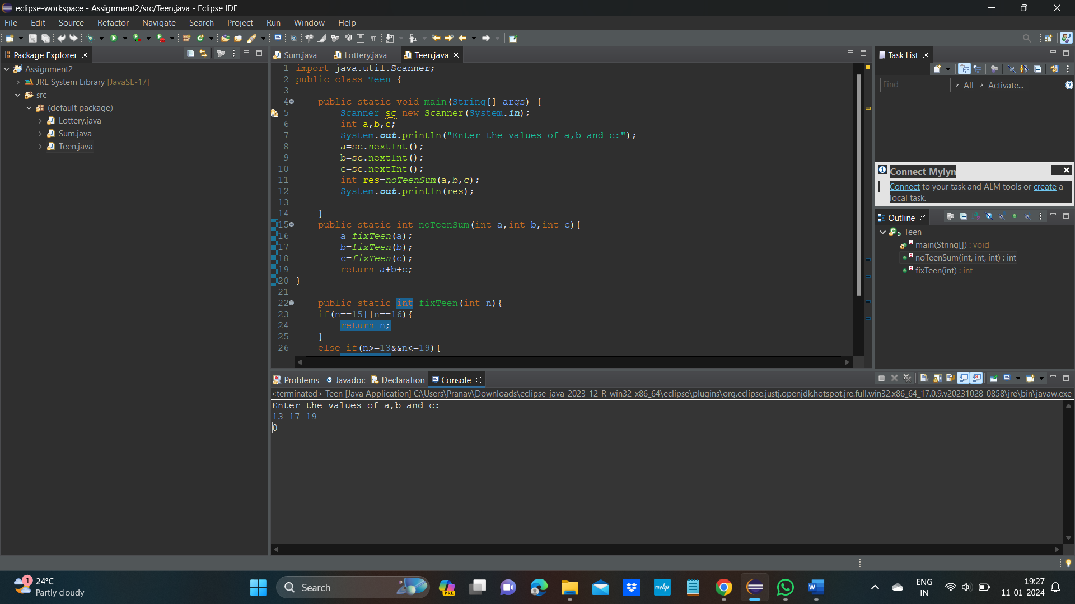

**Ques 03: Green lottery ticket**

**Java code:**

import java.util.Scanner;

public class Lottery {

public static void main(String[] args) {

int a,b,c;

Scanner sc=new Scanner(System.***in***);

System.***out***.println("Enter the values of a,b and c: ");

a=sc.nextInt();

b=sc.nextInt();

c=sc.nextInt();

if(a==b && b==c) {

System.***out***.println("the result is:20");

}

else if(a==b || b==c || a==c) {

System.***out***.println("the result is: 10");

}

else {

System.***out***.println("the result is: 0");

}

}

}

**Output for ques 03:**

